|  |
| --- |
| EPAM Systems, RD Dep. |
| MTN.BI.08 Dimension Table Techniques |

|  |  |  |  |  |  |
| --- | --- | --- | --- | --- | --- |
| REVISION HISTORY | | | | | |
| Ver. | Description of Change | Author | Date | Approved | |
| Name | Effective Date |
| 1.0 | Initial status | [Kiryl Bucha](mailto:Kiryl_Bucha@epam.com) | 12-JAN-2012 |  |  |
| 2.0 | Updated in accordance with renewed content | [Elias Nema](mailto:Elias_Nema@epam.com) | 20-JAN-2014 |  |  |
| 3.0 | Report on the task | Aksana Kuratnik | 21-NOV-2017 |  |  |

Contents

1. Create Geo Hierarchy 3

2. Dimension Hierarchy Analysis 5

# Geo Hierarchy

Query was made on the data from on the staging layer from the previous task.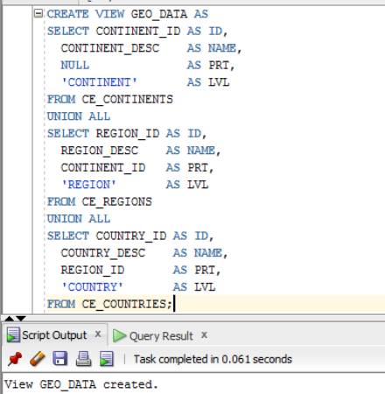

The result of query is 269 rows.

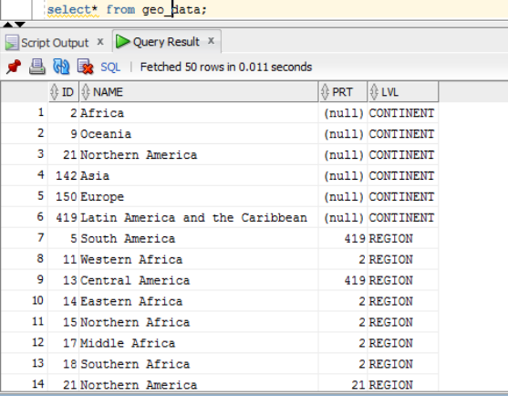

Required points:

Denormalized structure data using CONNENT_BY with additional columns - Branch, ROOT, Leaf, Count of children of Branch or Root, Full path of Dependencies by Example: ROOT -> BRANCH -> BRANCH -> LEAF:

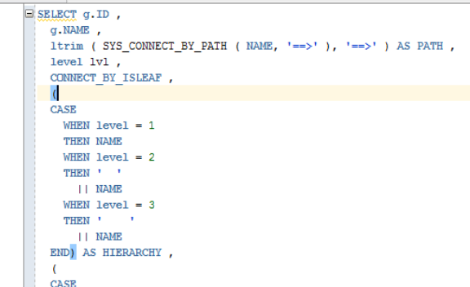

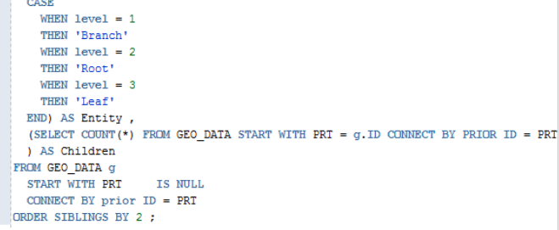

The result is 269 rows as in the basic view:

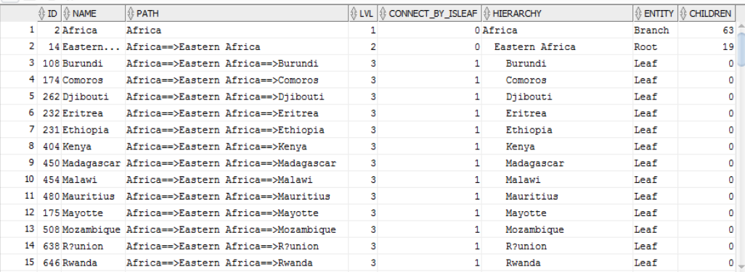

# Dimension Hierarchy Analysis

The analog of the previous query, but recursive WITH clause is used here instead of CONNECT BY:

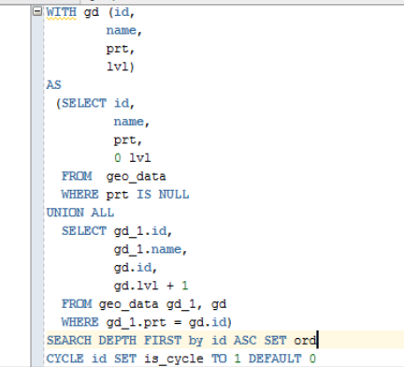

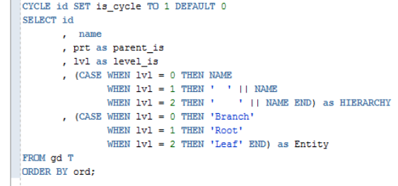

The result is the same 269 rows:

